**Christopher King**

**2018141521058**

**Mechanical Design 2**

**Class Section 01**

**10/25/2021**

# **Problem 1**

(Continued from HW06, Question 02) 1. An angular-contact, inner ring rotating, 02-series ball bearing is required for an application in which the life requirement is 40 kh at 520 rev/min. The design radial load is 725 lbf. The application factor is 1.4. The reliability goal is 0.95. Determine

1. multiple of rating life xD,
2. minimum C10, catalog rating C10, and bearing selection corresponding to Table 11–2; and
3. the existing reliability in service.

**Solution:**

Minimum C10

I select the bear with bore in Table 11-2 with catalog rating .

# **Problem 2**

(Continued from HW06, Question 03) The other bearing on the shaft of Question 02 to be a 03-series cylindrical roller bearing with inner ring rotating. For a 2235-lbf radial load, find the catalog rating C10 with which to enter Table 11–3. The reliability goal is 0.90. Choose a bearing and estimate its reliability in use.

**Solution:**

I select the bear with bore in Table 11-3 with catalog rating .

# **Problem 3**

Questions 01 and 02 raise the question of the reliability of the bearing pair on the shaft. What is the reliability of the two bearings (probability that either or both will not fail) as a result of your decisions in Probs. 1 and 2?

**Solution:**

# **Problem 4**

The worm shaft shown in the figure transmits 1.2 hp at 500 rev/min. A static force analysis gave the results shown in the figure. Bearing A is to be an angular-contact ball bearing selected from Table 11–2, mounted to take the 555-lbf thrust load. The bearing at B is to take only the radial load, so an 02-series cylindrical roller bearing from Table 11–3 will be employed. Use an application factor of 1.2, a desired life of 30 kh, and a combined reliability goal of 0.99, assuming distribution data from manufacturer 2 in Table 11–6.

Specify each bearing.

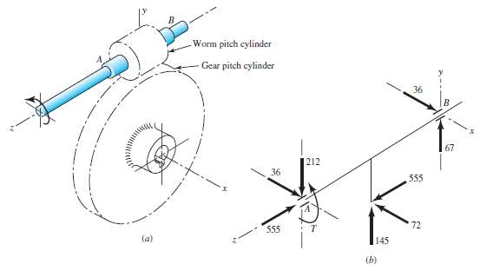

**Solution:**

For bear B:

Try ,

The smallest in Table 11-3 is . Therefore, I select the bear with bore in Table 11-3.

For bear A:

Try bore in Table 11-2 with catalog rating .

Interpolate using Table 11-1:

Therefore,

Therefore, we try bore in Table 11-2 with catalog rating again.

Interpolate using Table 11-1:

Therefore,

Therefore, bore in Table 11-2 is suitable.